**Unified Modelling Language(UML) For Diabetes Prediction**

1.Class Diagram :

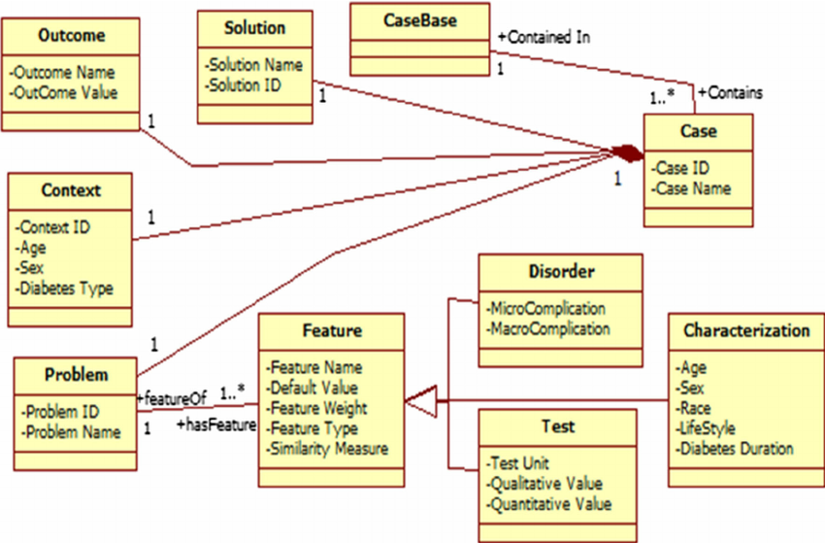

classes-Outcome,solution,Casebase,case,context,feature,disorder,test,problem,characterization.

**2.Usecase Diagram:**

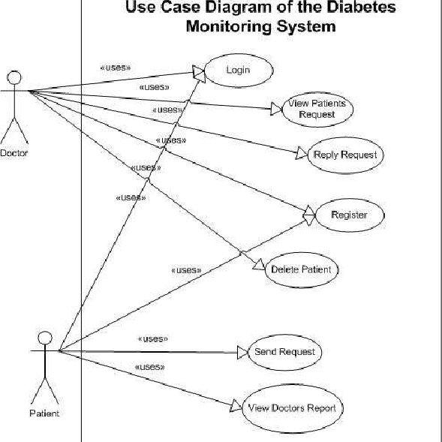

3.Sequence Diagram:

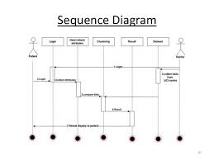

4.Activity Diagram:

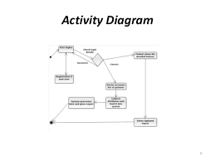

**Team Members:**

RAKESH KASIRE NADUKUDA

MARAM SHYAM GOPAL REDDY

KANDIMALLA AKHILA

HARINI REDDY